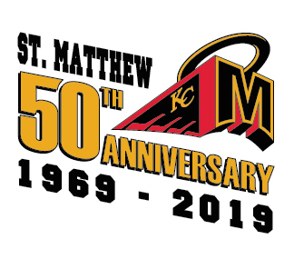
DATE

Dear Potential TEAM NAME Supporter:
The St. Matthew Hockey Club’s TEAM NAME hockey team is a minor hockey team comprised of players living on the Northside of Edmonton. Our team has a modest operating budget that must be fulfilled by parent contributions, donations and fundraising by our families.
As a team we have taken on the task to seek sponsorship from our local community businesses.
Our focus is to ensure that every player has the ability to play and develop their skills regardless of their family background/situation.
At this time, we would like to ask for your generosity and support for our team. Your kind contribution would be used to offset the expenditures for our players concerning tournaments, ice time and power skating lessons.
We greatly appreciate any support you can offer to our young athletes.

Yours in Community Youth Sports,

YOURNAME
Team Manager
KC St. Matthew Hockey Club TEAMNAME

